Morongo Basin Transit Authority
September 2, 2021

Notice of Intent to Award MBTA RFP 21-01 for Bus Shelters

The MBTA staff has evaluated the bid submitted in response to the subject solicitation. Based on the evaluation criteria contained in the solicitation, the following firm is proposed to be included in the Local Government Purchasing Schedule for the provision of bus shelters and accessories:

Tolar Manufacturing, 258 Mariah Circle, Corona California, 92879: Award for highest RFP score.

MBTA reviewed the bid submitted by the firm and found them technically responsive to the solicitation.

If there are other questions regarding the recommendation, please contact the undersigned at 760-285-3479 or joe@mbtabus.com.

Sincerely,

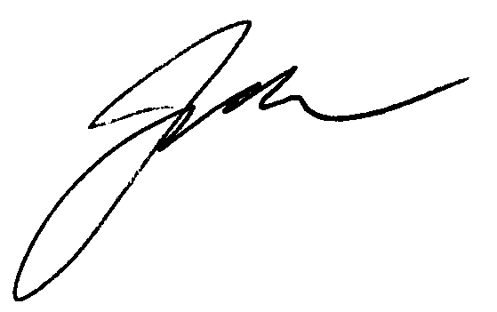

Joe G. Meer
General Manager

