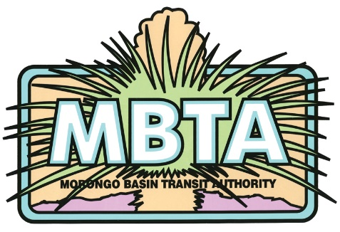

Transit Mechanic

The Morongo Basin Transit Authority is seeking a Mechanic for hire.

The successful candidate will perform preventative maintenance including but not limited to diagnostics, service and repair of steering suspension, brakes, engines, transmissions, differentials, electrical systems, wheelchair lifts, and air conditioning systems. Medium and heavy-duty vehicles powered by Compressed Natural Gas (experience a plus).

- Must be a team player willing to work flexible schedules, be a self-starter and willing to take on various tasks such as facility maintenance or other duties as assigned.

- Good driving record is a must and the ability to obtain a Class B license is required. Must provide own tools.

- The MBTA has a competitive wage schedule and benefits package that applies to this position. Specialized training for transit vehicles will be provided post-hire.

Apply in person at the Morongo Basin Transit Authority, 62405 Verbena Road, Joshua Tree, Ca 92252 or visit us on the web to print the application: https://mbtabus.com/careers/

Apply attention: Matt Atkins, Operations Manager 760.366.2986 ext. 112 matt@mbtabus.com

